**Programming Lab 4**

Winter 2023

Email Service

**Prepared by**

* Abdelrahman Mohamed
* Abdelrahman Wael
* Ahmed Hesham
* Mohamed Amin

PREPARED BY

**Ahmed Hesham**

**Abdelrahman Wael**

**Mohamed Amin**

**Abdelrahman Abdelmotelb**

1

**Manage your emails with our Web-based email service application**

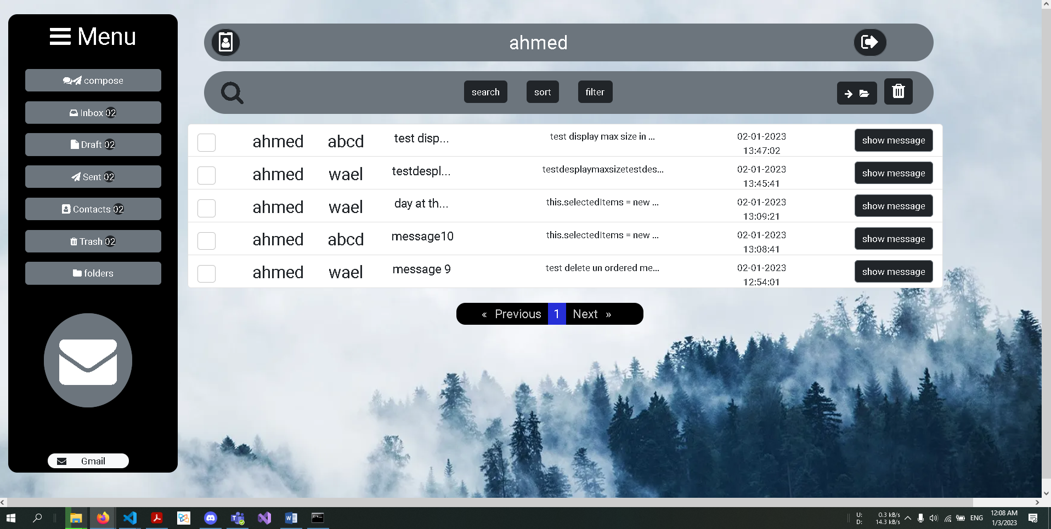

* **Functionalities**

|  |  |
| --- | --- |
| * **Attach files with your message** | * **Trash for unimportant messages** |
| * **Draft messages to finish later** | * **Group messages in folders** |
| * **Save, Edit and Delete your contacts** | * **Lexicographic sorting for contacts** |
| * **Search for message or contact** | * **Five levels for message priority** |
| * **Pagination** | * **Message filtering** |

2

**1. Run npm install on your terminal**

**2. Install the import npm install ngx-pagination**

**3. Also install npm i bootstrap-icons**

**4. Finally run the app using ng serve**

3

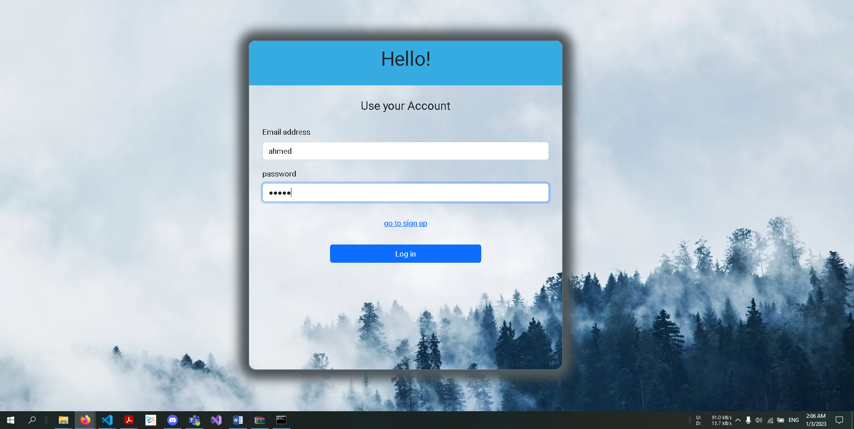**1. Log in your account**

**2. Sign up if you are new**

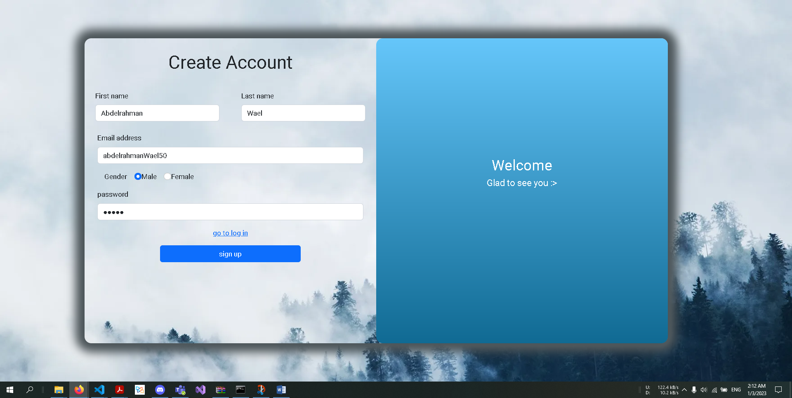

**3. Send a message using Compose button**

**4. Your inbox**

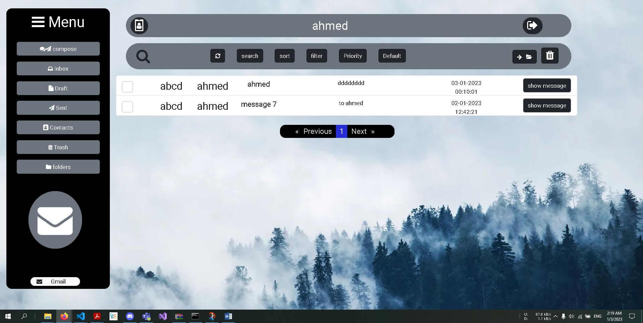

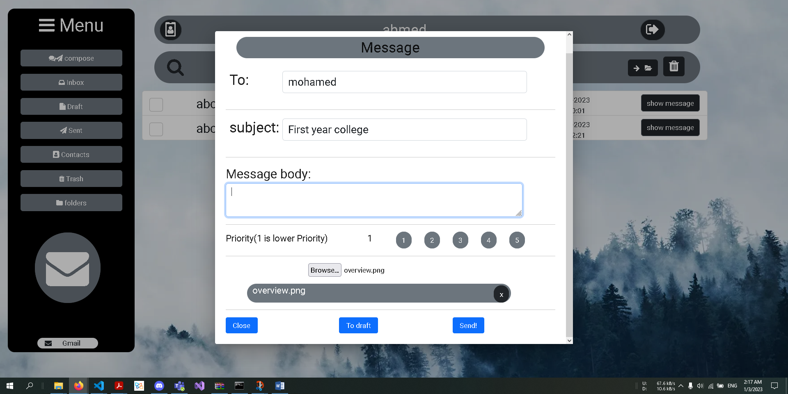

**5. You can sort the messages**

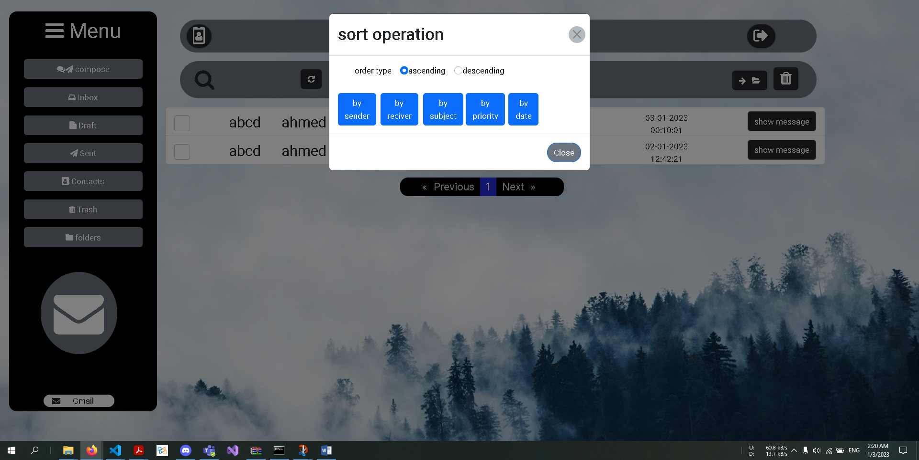

**6. Filter**

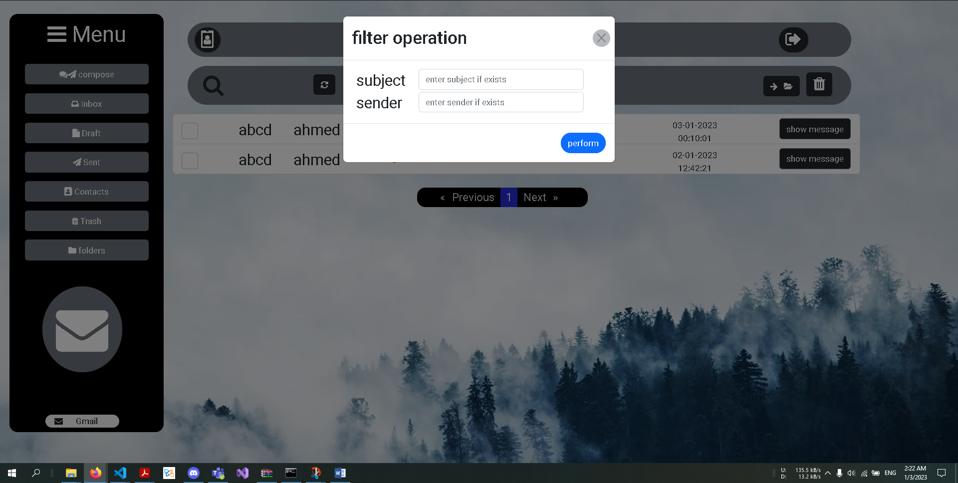

**7. Here are your Contacts**

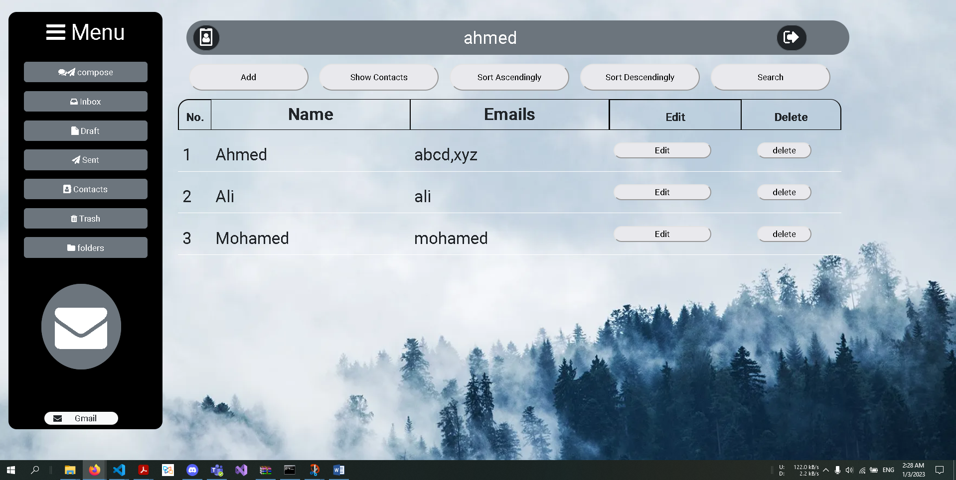

**8. Create folders**

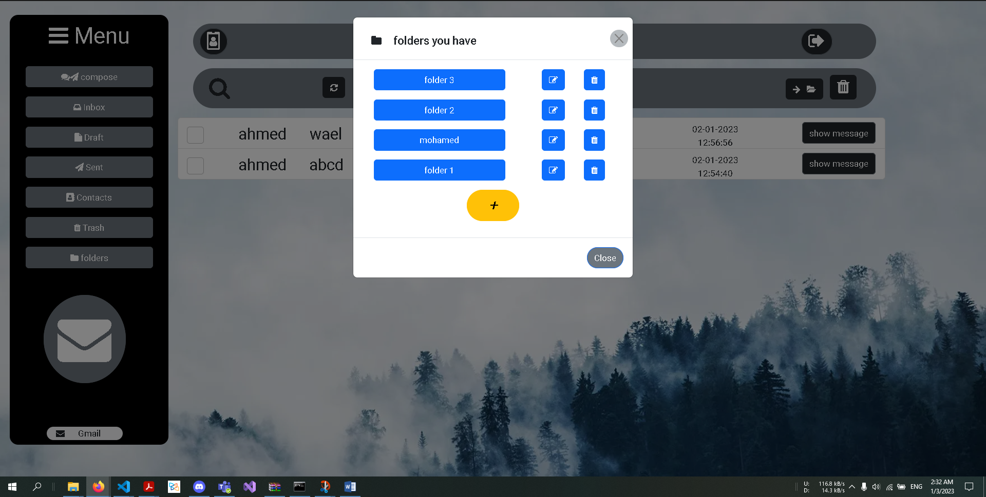

4

**Backend**

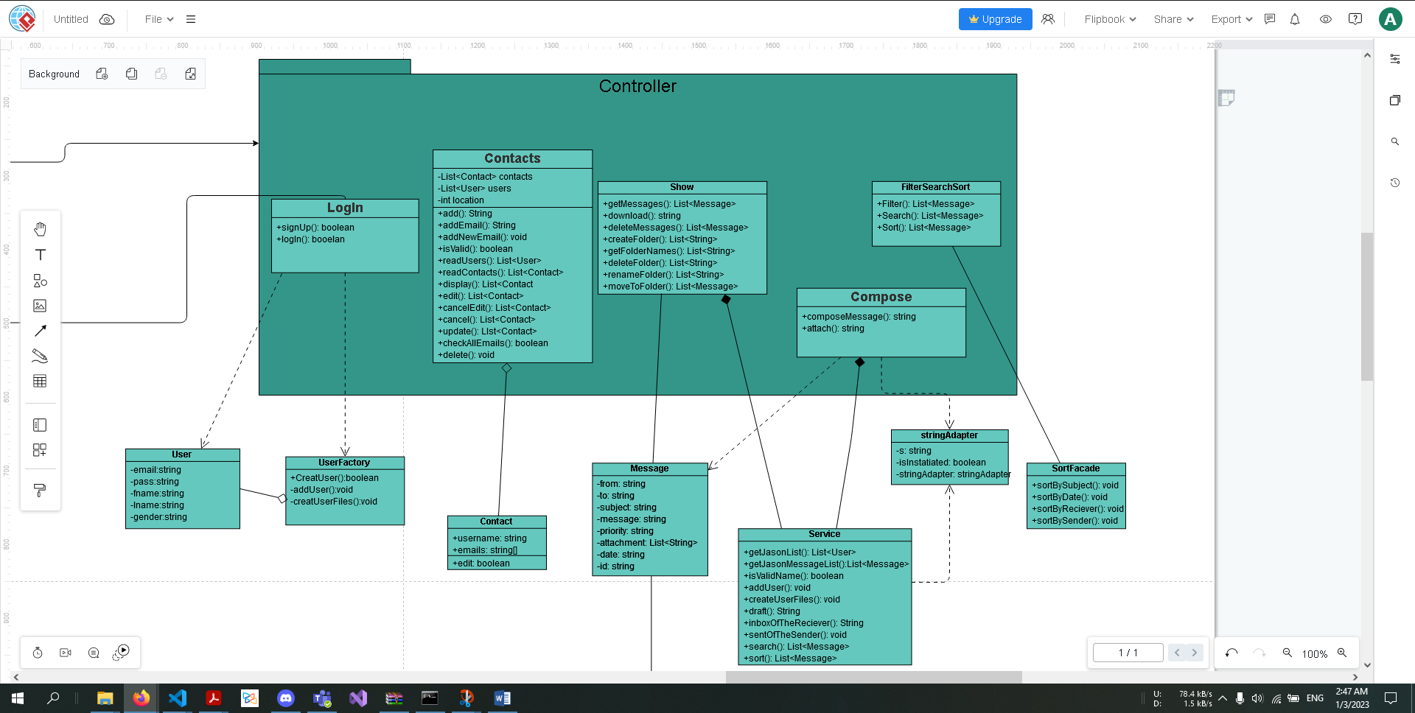

**..Backend Filter**

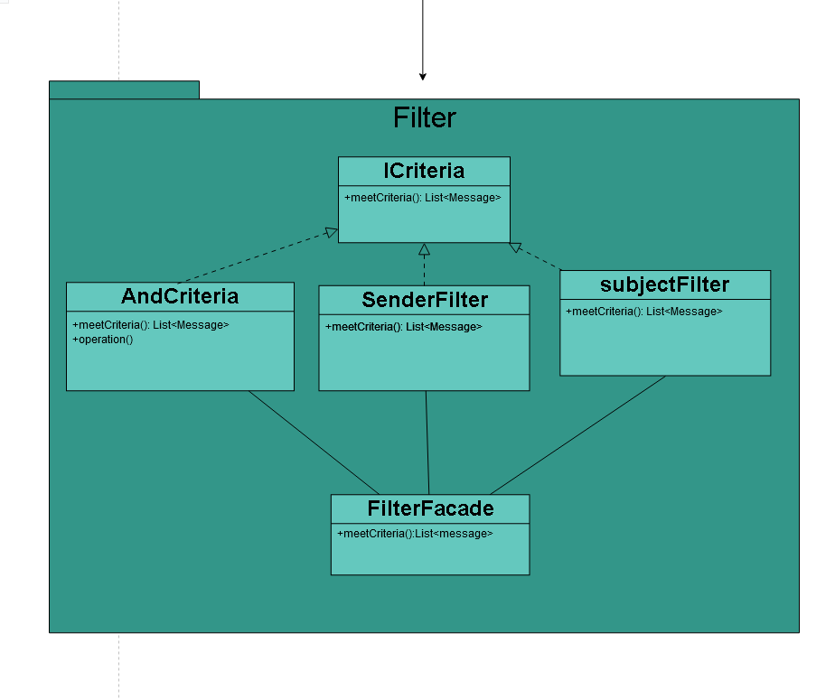

**Front end**

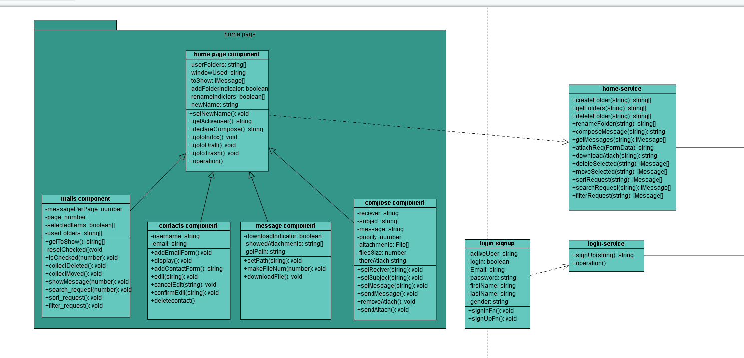

**UML Link:** [**https://drive.google.com/file/d/1MuuQV_Ub4P2HBO4QYNaqj1w1z0YR-Kri/view?usp=sharing**](https://drive.google.com/file/d/1MuuQV_Ub4P2HBO4QYNaqj1w1z0YR-Kri/view?usp=sharing)

5

***1. Builder***

**A message builder for constructing complex object (message). So the client isn’t exposed to the details of object creation.**

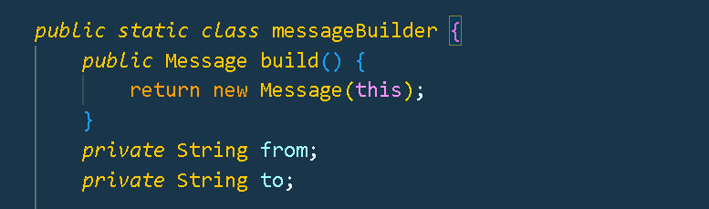

***2. Singelton***

**Assuring that only one instance of a class is created. Any object that deals with the class will be the same instance.**

***3. Adapter***

**Used to convert all incoming strings for the class to List of objects**

***4. Filter***

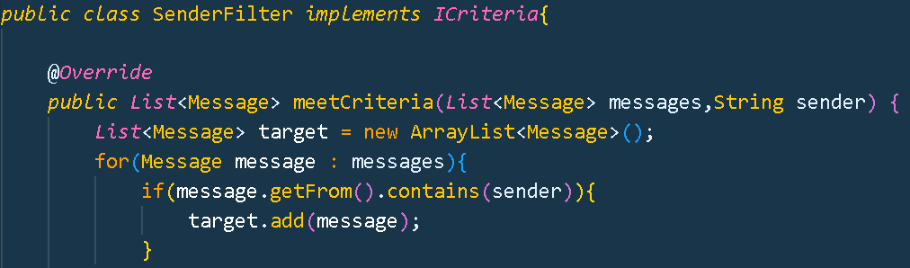**Implemented the criteria pattern to filter message details. Using the “AndCriteria” to filter sender and subject concurrently**

***5. Façade***

**To simplify the access to all related objects by providing a single object to communicate with the set.**

***6. Factory***

**Create User object without exposing the creation logic to the client and refer to newly created object where the user is created with its required attributes and intial files.**